Lac La Hache Elementary School

4787 Clarke Ave
Box 128
Lac La Hache, BC V0K 1T0
Phone: 250-396-7230 Fax: 250-396-4092
Principal: Shawn Nelson

SEPTEMBER 15,2022

- Sept 19th - Queen Elizabeth Funeral
(No School)
- Sept 22nd - Terry Fox Run

- Sept 23rd - PRO D DAY (No School)
- Sept 28th - Picture Day
- Sept 29th - Orange Shirt Day
- Sept 30th - Nation Day of Truth
(No School)

Principals Message

The Staff of Lac la Hache Elementary would like to welcome all the new families and students back to school. We are looking forward to having a wonderful year of learning and new adventures with the students. The startup will align with the Ministry of Education guidelines and is in accordance with the health guidelines for K-12 schools from the Provincial Health Office.
Reminder:
- Complete a daily health check.
- Stay home when sick.
- Get vaccinated
- Daily health check app@k12dailycheck.gov.bc.ca

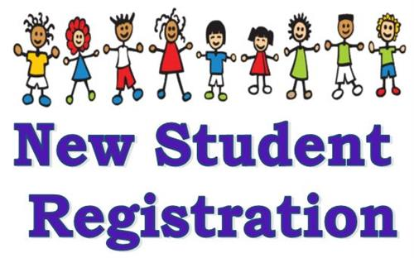
Student Registration is still available at Lac la Hache Elementary, please contact the office for more further information. 250-396-7230.


Queen Elizabeth II Funeral
On Monday Sept 19 2022 the school will be closed due to the funeral of Queen Elizabeth II.

Professional Development Day
September 23,2022 there will be no school due to the Professional Development Day.
Student Picture Day
The students of Lac la Hache Elementary will be having their pictures taken on Sept 28,2022 after recess. Please come and show off your best smiles.


Terry Fox Run will be on September 22,2022, the students will be doing activities and will also have the opportunity to donate money if they choose, and for every dollar that is donated their name will go on a shoe that will be posted in the school hallway.

Oranage Shirt Day will be on September 29th 2022,please wear your shirts.

 September 30 is the National Day of Truth and Reconcilliation there will no schooL.

PAC
Thank you for the support that the PAC has given the school and we appreciate the time that you have put into making Lac la Hache a better place for students. The PAC are looking for new parents to join the team to help make the school a more welcoming place. We also appreciate the community members that continue to support our food programs at our school.

Electronic Newsletters from LLH and the PAC 

We have started to send school newsletters and PAC updates home electronically. If you would like to receive your school newsletters and PAC updates by e-mail, please let the office know and they will arrange it for you.


Meals Program
Our grab-and-go breakfast program
has been very successful and will
continue for the remainder of this
year.

If you have any further questions or concerns, please feel free to contact the office @ 250-396-7230

